**The story of our pockets**



Our Finance

***“You must be the change you wish to see in the world.”***

This is our real motivation and for this change to come true we had to plan and execute every step very carefully , as “losing” here just doesn’t mean loss to our company but, to our dream of sustainable rooftop concept. So we followed a mantra” ***Being good is good business”***

**They believed in US:** 

Thank god, we found few people who believed in our vision and helped us reach every milestone. We are proud to share our success stories with our partner and investors. It was slow and small investment but as time passed and as the news of our idea spread, we made our way. Few investors turned and also became our partners.

Our Sponsors! Our Supporters!!:



We are blessed to have some wonderful people around us, who stood like rock during our initial days of building this whole new business. And made our tiny steps transform into a whole new journey.

There are many NGO ‘s who equally believed that sustainability in agriculture is just not need but necessity .

We are happy to have organizations like Greenpeace Canada, International Council for Local Environmental Initiatives (ICLEI) Nature Canada, The Hope Farm.

Vocational Training programmes, Financial assistance and counselling to handle the different phases of business journey were few most valued help we enjoyed.

We heart fully thank our government for benefiting us with schemes like **Canadian Agricultural Loans Act,**  which not just gave us hope and but helped us put our best foot forward always.

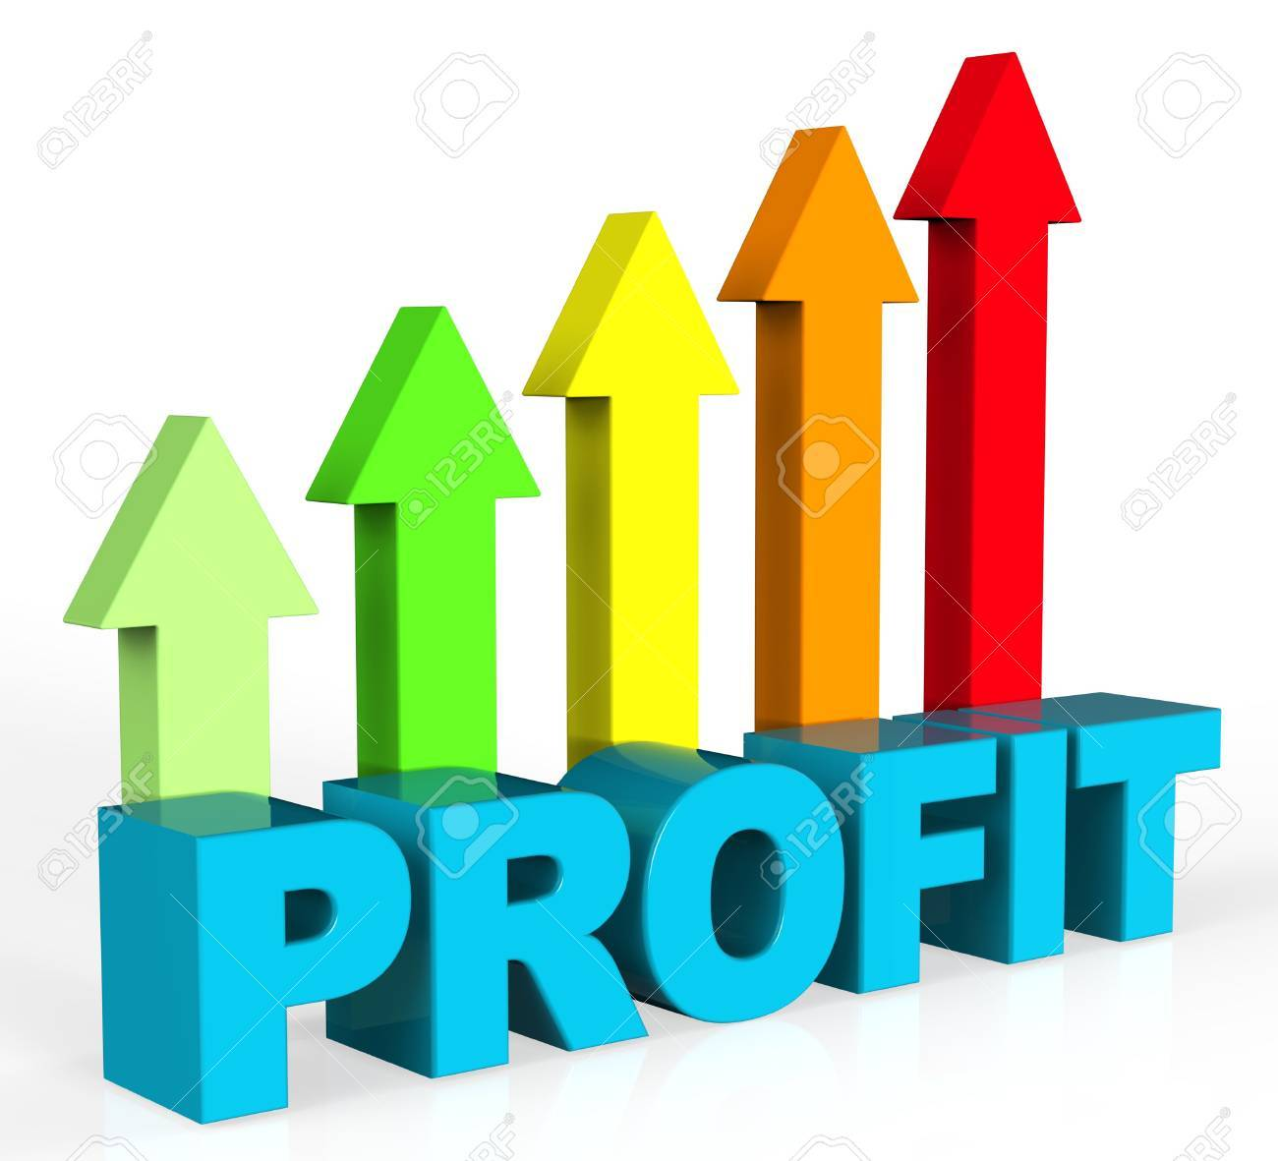

Where do get our profit from:

Hip Hip Hurray!!!!Happy to share the news that after all the expenses we spent i.e. from renting to area, buying the raw material, hiring the staff , renting the machinery, setting up the structure, maintaining expenses and manufacturing expenses we finally landed up with good revenue from past three years. It was only and only possible because our Customers loved our products.

|  |  |  |  |  |  |  |  |
| --- | --- | --- | --- | --- | --- | --- | --- |
| **NET PROFIT MARGIN** | | | | | | | |
|
| **Costco** |  | **2019** |  | **2020** |  | **2021** |  |
| Revenue |  | $200000 |  | $300000 |  | $350000 |  |
| Net Profit |  | $20000 |  | $35000 |  | $45000 |  |
| **NET PROFIT MARGIN** | | 10% |  | 13.50% |  | 20% |  |

Still there is long way to go and celebrate many more milestones , reach more people .